City of Seaside
2020
Amended CITIZEN PARTICIPATION PLAN

A Citizen Participation Plan must be followed in preparation of CDBG Plan documents including (but not limited to): Consolidated Five Year Plan, the Annual Action Plan and the Consolidated Plan Annual Performance Report (CAPER).

Due to a variety of circumstances, HUD has mandated all agencies amend their Citizen Participation Plans reflecting the process utilized to prepare for the 2020 submissions. Seaside’s Citizen Participation Plan was revised as follows starting in early 2020:

The Council approved work plan for the Homeless Commission indicates that it can assist the CDAC. Due to unexpected vacancies on the CDAC, our HUD rep indicated that a joint meeting with the two groups would meet the HUD approved Seaside plan requirements A special meeting was scheduled and notice was posted per regular procedures including email to the Community Development Advisory committee email list on BCC. The list includes over 60 opt-in emails (not included as an attachment for privacy).Note: the list received emails regarding all meetings referenced in this document.

Eight citizen volunteers discussed the applications during the special meeting on March 11, 2020, as social distancing was just beginning to be discussed and Shelter In Place was not yet instituted. As was also the case in the 2018, cycle the deliberations were verbal and conducted in a noticed and recorded public meeting. The agenda packet can be accessed at https://seasideca.civicclerk.com/Web/UserControls/DocPreview.aspx?p=1&aoid=1936 and is attached as Attachment 1.

The approximate 90 minute meeting can be viewed at
https://www.youtube.com/watch?v=4uKhXZvupFo&t=12s

Following recommendations from the joint committee, a report was prepared for consideration at City Council on March 19 for direction to staff for items to be included in the Consolidated Plan/AAP. However, due to the COVID-19 pandemic the item was postponed.

The City adjusted meetings to transition to a more social-distance friendly format as follows:
Pursuant to Governor Newsom's Executive Orders N2920 and N3320 and to do all we can to help slow the spread of COVID19 (coronavirus) City of Seaside meetings were adapted in the following ways:
- Members of the public may participate before and during each meeting by submitting comment(s) to cityclerk@ci.seaside.ca.us. The clerk will read each received public comment aloud into the record at the designated time, subject to time limits that may be imposed pursuant to the Brown Act. In the subject line of a public comment email, please specify the meeting body and date and indicate the relevant item number or "general" to help staff easily receive and organize public comments.

- Meetings of the Seaside City Council and its Boards and Commissions will be conducted with virtual (electronic) participation only. Members of the public may watch the live stream of the City Council and Boards and Commission meetings at https://bit.ly/SeasideYouTube
Seaside submitted a waiver to HUD regarding extension of deadlines on April 6. The waiver is Attachment 2.

HUD released information regarding CARES Act funding to be awarded to address COVID-19. The City had paused boards, commissions and committee meetings unless deemed necessary. As a result, regular Community Development Advisory Committee Meetings were not held.

A special virtual CDAC meeting was held on April 27. Two members attended the agendized meeting and a discussion of the possibilities took place to preview the CDBG-CV possibilities prior to the May 21 City Council scheduled direction to staff. The discussion included emailed public comment. The agenda packet can be accessed at
https://seasideca.civicclerk.com/Web/UserControls/DocPreview.aspx?p=1&aoid=1948 and is attached as Attachment 3

The meeting can be viewed at https://www.youtube.com/watch?v=LkPACYltxKA&t=95s

The Council discussed the recommendations on Thursday, May 21 during a virtual City Council meeting. A link to the full agenda and reports is available at https://seasideca.civicclerk.com/Web/Player.aspx?id=3601&key=-1&mod=-1&mk=-1&nov=0

City Council items10A and 10B on May 21, 2020 to provide direction to staff for preparation of the CON/AAP for CDBG and CDBG-CV funds are Attachments 4 and 5 respectively. This was a virtual meeting.

City Council recommendations for funding for CDBG video link of the Council Meeting at https://www.youtube.com/watch?v=K_PVVnWYDkA
Item 10 A for direction on use of CDBG funds begins at 2:05 through 3:47. Written public comment received by the City Clerk via email was read into the record above.

CDBG-CV was discussed on item 10 B linked at https://www.youtube.com/watch?v=K_PVVnWYDkA
from 3:47 through 4:31. Written public comment received by the City Clerk via email was read into the record above.

These two topics concerning the CDBG program were discussed for a total of 2 hours and 26 minutes during the May 21 virtual City Council meeting.

The Consolidated Plan (including the 2020-2021 Annual Action Plan featuring the CDBG-CV fund plan as part of the upcoming projects), and the Amended Citizen Participation Plan were posted online due to the unavailability of public viewing locations. A shortened five day public review period as approved by HUD for the special circumstance was observed. A copy of the notice will be included in the public comment section of the submission to HUD via IDIS program.

A Public Hearing will take place using virtual meeting process indicated above will take place to discuss the Consolidated Plan/Annual Action Plan and Amended Citizen Participation Plan followed by adoption of a resolution to adopt all and submit documentation requested to HUD. A copy of the Draft Resolution is Attachment 6.

It is expected a subsequent revision to the Citizen Participation Plan will occur as the City considers restructuring of Boards and Commissions citywide as a result of the impacts of COVID-19.

ATTACHMENT 1

Agenda Packet: Joint Community Development Advisory Committee/Homeless Commission Meeting

March 11, 2020

ATTACHMENT 1A Draft Meeting Minutes

ATTACHMENT 2

City of Seaside waiver to HUD

ATTACHMENT 3

Agenda Packet: Special Community Development Advisory Committee meeting

April 27, 2020

ATTACHMENT 3A

Meeting Notes

ATTACHMENT 4

Item 10A. City Council Meeting (CDBG Direction to staff 2020-2021)

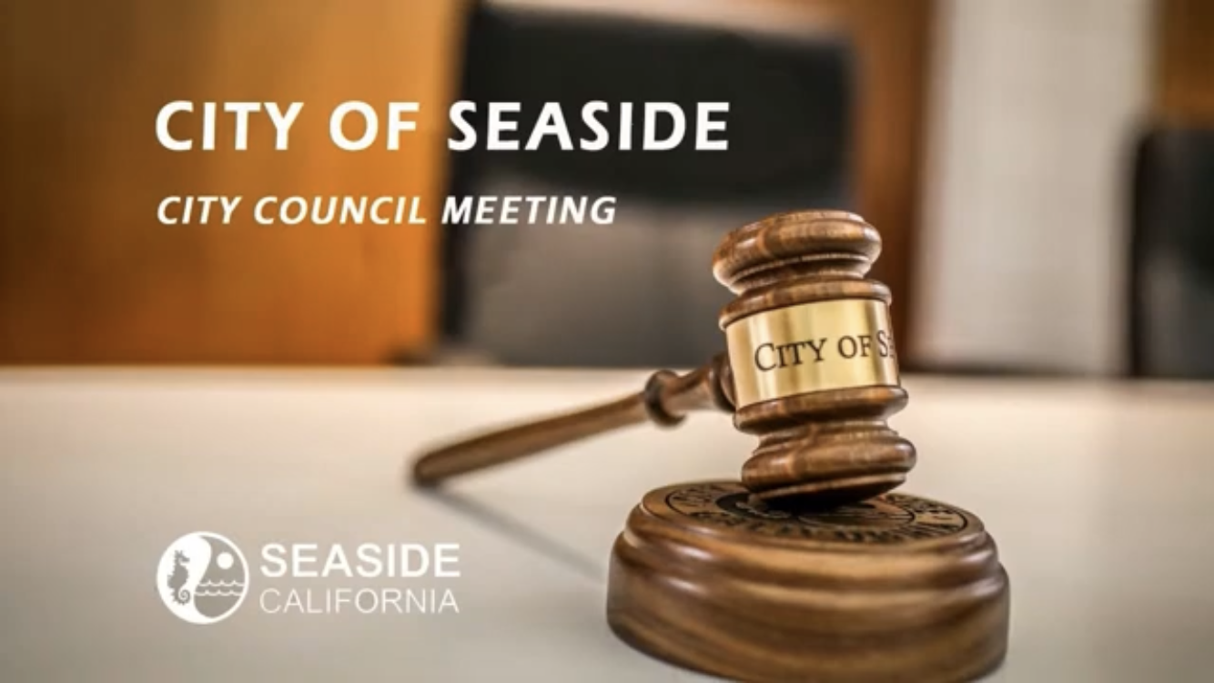

May 21, 2020

Attachment 4 A Staff Report
Attachment 4 B Outreach to Applicants
Attachment 4 C PowerPoint

ATTACHMENT 5

Item 10B City Council Meeting. (CDBG-CV Direction to Staff)

May 21, 2020

Staff Report

ATTACHMENT 6

Draft Resolution approving Consolidated Plan, Annual Action Plan (including CDBG-CV) and Amended Citizen Participation Plan

RESOLUTION No. 20-XX

A RESOLUTION OF THE CITY COUNCIL OF THE CITY OF SEASIDE

APPROVING THE 2020-2025 FIVE YEAR CONSOLIDATED PLAN AND 2020-2021 ANNUAL ACTION PLAN AND ASSOCIATED DOCUMENTS FOR THE

COMMUNITY DEVELOPMENT BLOCK GRANT (CDBG) PROGRAM

WHEREAS, Title 1 of the National Affordable Housing Act requires recipients of Federal funds from the Department of Housing And Urban Development (HUD) to develop a Five-Year Consolidated and related Annual Action Plan; and

WHEREAS, the City of Seaside as a recipient of Community Development Block Grant (CDBG) funds, is submitting for approval its 2020-2025 Five Year Consolidated Plan to HUD; and

WHEREAS, the 2020-2021 Annual Action Plan has been prepared as the first year of implementation of the strategies in the Five Year Consolidated Plan; and

WHEREAS, on November 7, 2019, the City posted and published a Notice of Funding Availability (NOFA) and Mandatory 2020-2022 CDBG Application Workshop which solicited applications for CDBG funded programs and projects and notified the public of the annual planning process for CDBG funding; and

WHEREAS, the Community Development Advisory Committee (CDAC) and the Homeless Commission met jointly on March 11, 2020 to discuss applications and to formulate public service and eligible projects funding allocation recommendations to the City Council; and

WHEREAS, the City received notification of special CDBG-CV funds to specifically address the COVID-19 pandemic; and

WHEREAS, the City submitted a waiver request to HUD to modify deadlines and standard public participation due to the COVID-19 pandemic, prompting an amendment to the Citizen Participation Plan; and

WHEREAS, the City Council modified the CDAC and Homeless Commission’s recommendations for public service and eligible projects funding as well as giving direction to staff for CDBG-CV funding to be included in the 2020-2021 Annual Action Plan at its May 21, 2020 regular meeting; and

WHEREAS, pursuant to Federal regulations, the City did hold the required public hearing on XXXX 2020 after public notice; and

NOW, THEREFORE BE IT RESOLVED, by the City Council of the City of Seaside that the 2020-2025 Five Year Consolidated Plan and the 2020-2021 Annual Action Plan, for the Community Development Block Grant program, including the CDBG-CV allocation, covering the designated periods, marked “Exhibit A” the amendment to the Citizen Participation Plan, marked “Exhibit B” and made a part hereof, is hereby approved for submittal and the City Manager is hereby authorized to sign and submit the Application for Federal Assistance (SF-424) and all certifications, assurances and other documents as may be required by HUD.

PASSED AND ADOPTED at a regular meeting of the City Council of the City of Seaside duly held on the XX of XX 2020.

AYES:

NOES:

ABSTAIN:

____________________

Ian N. Oglesby
Mayor

Attest:

_____________________

Lesley Milton
City Clerk

